PROJECT REPORT
AUTO-TICKET CLASSIFICATION USING FLOW DESIGNER
An automated IT helpdesk ticket categorization solution built on ServiceNow
Submitted by: Kanna Jyothi Swarupa, Chemarthi Shalini, Kaduru Geethika.
Team ID : SWTID-2026-7810
Platform: ServiceNow (Flow Designer)

Table of Contents
1. INTRODUCTION

1.1 Project Overview
Auto-Ticket Classification using Flow Designer is a no-code automation project built on the ServiceNow platform for a school IT helpdesk. The helpdesk receives a steady stream of support requests from students and teachers covering network connectivity, hardware failures, account access problems and system performance issues. Until now, IT staff had to open every ticket, read the description, decide what kind of problem it was, and manually pick the correct Category and Subcategory before work could begin.
This project removes that manual step. When a user raises a new ticket, they only enter two details: the Caller Name and a Short Description of the problem. The moment the ticket is submitted, a Flow Designer flow is triggered. The flow inspects the Short Description for predefined keywords (WiFi, Projector, Password, Login, Slow, Hanging) and, based on the keyword found, automatically sets the matching Category and Subcategory on the ticket. The caller is then informed that the ticket has been created through an email notification.
The entire solution is configured using ServiceNow Flow Designer without writing application code, which makes it easy to maintain, extend and hand over to non-developers.
Key capabilities:
- Minimal ticket entry: only Caller Name and Short Description are required.
- Automatic, rule-based assignment of Category and Subcategory on record creation.
- Consistent classification that does not depend on who reviews the ticket.
- Email notification to inform the caller that the ticket has been created.
- Fully no-code, visual implementation that is easy to modify as new keywords are needed.

1.2 Purpose
The purpose of this project is to automate the first and most repetitive step of IT support, which is ticket triage, so that support staff can spend their time resolving issues rather than sorting them. The specific objectives are:
- To eliminate manual identification and categorization of incoming tickets.
- To reduce human error and mislabelled tickets by applying the same keyword rules to every request.
- To make the process scalable, so that rising ticket volumes do not require additional triage effort.
- To keep the user experience simple, so students and teachers do not need to understand the category structure.
- To keep callers informed by sending a ticket-creation notification.
- To demonstrate a practical, production-style use of ServiceNow Flow Designer that can be reused for other departments.

2. IDEATION PHASE

2.1 Problem Statement
The school IT helpdesk receives multiple support requests every day from students and teachers. Each request has to be reviewed by IT staff, who must identify the issue type, select the correct category and subcategory, and inform the caller that a ticket has been created. This manual process is time-consuming, error-prone and does not scale as the number of requests grows.
Problem Statement Element | Description
I am | A student or teacher who faces an IT problem and needs help quickly.
I am trying to | Report the issue to the IT helpdesk and get it to the right person without extra effort.
But | Tickets are categorized by hand, so they are sometimes mislabelled or wait in a queue until someone sorts them.
Because | The helpdesk depends on manual review of every ticket, and the volume keeps increasing.
Which makes me feel | Uncertain whether my issue was understood and frustrated by delays.

2.2 Empathy Map Canvas
The empathy map below captures the perspective of the primary user, a student or teacher raising an IT support request, and the IT helpdesk staff member who receives it.
SAYS  "My WiFi is not working."  "The projector will not turn on, the class is waiting."  "Did anyone receive my request?" | THINKS  Why do I have to choose a category I do not understand?  Will my ticket reach the right person?  I just want this fixed so I can continue working.
DOES  Submits a short description of the problem.  Follows up with IT staff in person or by phone.  Re-submits tickets when there is no response. | FEELS  Frustrated by delays and disrupted classes.  Anxious when there is no confirmation.  Relieved when the ticket is acknowledged immediately.
PAINS  Unclear category selection, no instant acknowledgement, slow triage, inconsistent labelling by different staff. | GAINS  Simple ticket form, instant automatic classification, confirmation email, faster routing and resolution.

2.3 Brainstorming
Several approaches were considered for solving the triage problem. They were compared on effort, maintainability and fit for a school environment.
Idea | Description | Evaluation
Keep manual triage | IT staff continue to read and categorize every ticket. | Rejected: slow, error-prone, does not scale.
Mandatory category dropdowns for users | Ask the caller to pick Category and Subcategory. | Rejected: non-technical users often choose wrongly, and the form becomes longer.
Custom server-side script (Business Rule) | Write JavaScript that reads the description and sets fields. | Possible, but needs coding skills and is harder for non-developers to maintain.
Flow Designer keyword automation | Use a no-code flow with conditions on the Short Description. | Selected: visual, easy to maintain, quick to build and easy to extend.
AI / ML text classifier | Train a model to predict categories. | Deferred to future scope: needs training data and is more than the current need requires.

Selected idea: Flow Designer keyword automation, because it solves the problem with the least complexity, requires no code and can be extended by simply adding more conditions.

3. REQUIREMENT ANALYSIS

3.1 Customer Journey Map
The journey below follows a student from the moment a problem occurs to the moment it is resolved, showing how the automation improves each stage.
Stage | User Action | System Behaviour | User Experience
1. Problem occurs | Notices WiFi, projector, login or performance issue. | - | Frustrated, needs help.
2. Raise ticket | Enters Caller Name and Short Description only. | Incident record is created. | Quick and simple form.
3. Auto classification | No action required. | Flow triggers, scans keywords, sets Category and Subcategory. | Invisible, no effort.
4. Acknowledgement | Receives confirmation. | Email notification informs the caller of ticket creation. | Reassured that the issue was received.
5. Assignment and resolution | Waits for the fix. | Correctly categorized ticket reaches the right IT staff. | Faster resolution.
6. Closure | Confirms issue resolved. | Ticket is closed. | Satisfied.

3.2 Solution Requirement
Functional requirements
ID | Requirement
FR-01 | The system shall allow a user to create a ticket by entering only Caller Name and Short Description.
FR-02 | The system shall trigger a flow automatically when a new ticket record is created.
FR-03 | The flow shall check the Short Description for the keywords WiFi, Projector, Password, Login, Slow and Hanging.
FR-04 | If the description contains WiFi, Category shall be set to Network and Subcategory to WiFi.
FR-05 | If the description contains Projector, Category shall be set to Hardware and Subcategory to Projector.
FR-06 | If the description contains Password or Login, Category shall be set to Access and Subcategory to Forgot Password.
FR-07 | If the description contains Slow or Hanging, Category shall be set to Performance and Subcategory to Slow Computer.
FR-08 | The system shall notify the caller by email that the ticket has been created.
FR-09 | Only authorized users shall be able to modify ticket classification data.

Non-functional requirements
- Usability: the ticket form must be simple enough for students and teachers with no training.
- Reliability: classification must run on every new ticket without manual intervention.
- Maintainability: new keywords and categories must be addable by editing the flow, without code.
- Scalability: the flow must handle increasing ticket volume without extra staff effort.
- Security: role-based access control must protect ticket data from unauthorized changes.

Keyword to classification mapping
Keyword in Short Description | Category | Subcategory
WiFi | Network | WiFi
Projector | Hardware | Projector
Password / Login | Access | Forgot Password
Slow / Hanging | Performance | Slow Computer

3.3 Data Flow Diagram
The Level-1 data flow diagram shows how data moves from the caller through the ServiceNow Incident table and the Flow Designer automation, and how the classified ticket and confirmation return to the caller.
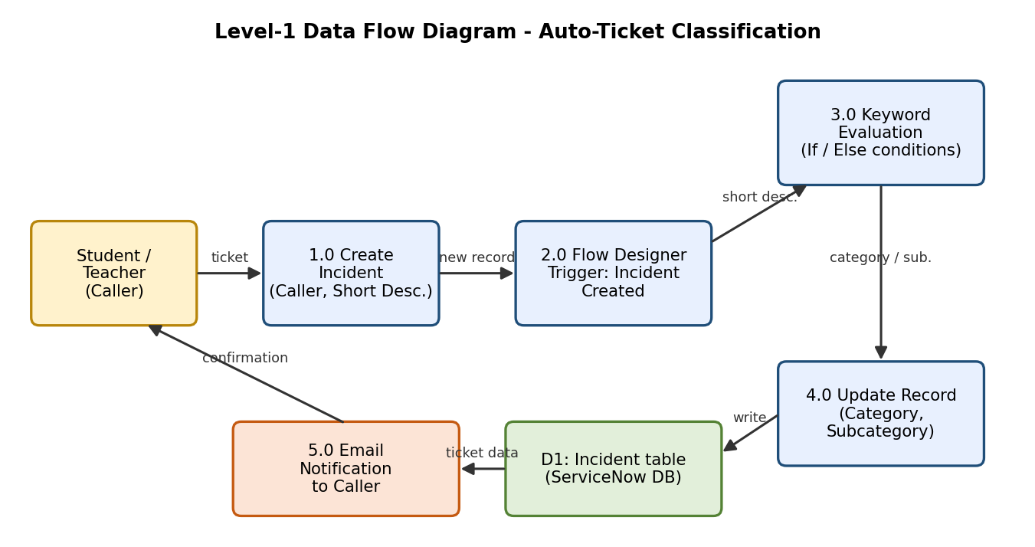
Figure 3.1: Level-1 Data Flow Diagram

3.4 Technology Stack
Layer | Technology | Purpose
Platform | ServiceNow (Personal Developer Instance) | Hosts the helpdesk application, tables and automation.
Automation | Flow Designer | No-code trigger, conditions and actions for classification.
Data | Incident table (Category, Subcategory, Short Description, Caller) | Stores ticket records and classification.
Notification | ServiceNow Email Notification / Send Email action | Informs the caller that the ticket was created.
Security | Roles and Access Control Lists (ACLs) | Restricts who can view and modify ticket data.
Testing | Flow test and execution logs, form-based test tickets | Validates end-to-end behaviour.

4. PROJECT DESIGN

4.1 Problem Solution Fit
Problem-solution fit confirms that the proposed automation addresses a real pain point for the target users. The mapping below connects each customer problem to the feature that solves it.
Customer Problem | Root Cause | Solution Feature | Benefit
Tickets are slow to be sorted. | Staff must read and categorize each one. | Automatic keyword classification on creation. | Instant triage.
Wrong categories on tickets. | Different staff judge differently. | Fixed, rule-based mapping. | Consistent classification.
Users do not know what to choose. | Category lists are technical. | User enters only a short description. | Simple experience.
No confirmation that the request was received. | Manual acknowledgement. | Email notification to the caller. | Reassurance and transparency.
Growing request volume. | Triage effort grows with volume. | No-code flow runs on every ticket. | Scalable support.

4.2 Proposed Solution
The proposed solution is a Flow Designer flow attached to the Incident table. It is triggered when a record is created and uses conditional logic on the Short Description to update the Category and Subcategory fields. A notification then informs the caller.
Aspect | Description
Trigger | Record Created on the Incident table.
Input | Caller Name and Short Description entered by the user.
Processing | Condition checks for keywords in Short Description (contains WiFi, Projector, Password or Login, Slow or Hanging).
Actions | Update Record to set Category and Subcategory; send email notification to the caller.
Output | A classified ticket in the Incident table and a confirmation to the caller.
Novelty | Zero-code triage that removes a daily manual task and can be extended by adding conditions.
Scalability | The same pattern can be reused for additional keywords, departments or priority rules.

Flow logic
- Trigger: a new Incident record is created.
- If Short Description contains "WiFi", update Category = Network and Subcategory = WiFi.
- Else if it contains "Projector", update Category = Hardware and Subcategory = Projector.
- Else if it contains "Password" or "Login", update Category = Access and Subcategory = Forgot Password.
- Else if it contains "Slow" or "Hanging", update Category = Performance and Subcategory = Slow Computer.
- Send the ticket-creation email notification to the caller.

4.3 Solution Architecture
The solution runs entirely inside the ServiceNow platform. The presentation layer captures the ticket, the Flow Designer layer performs the keyword evaluation and updates the data layer, notifications go out to the caller, and the security layer controls who can see or change the data.
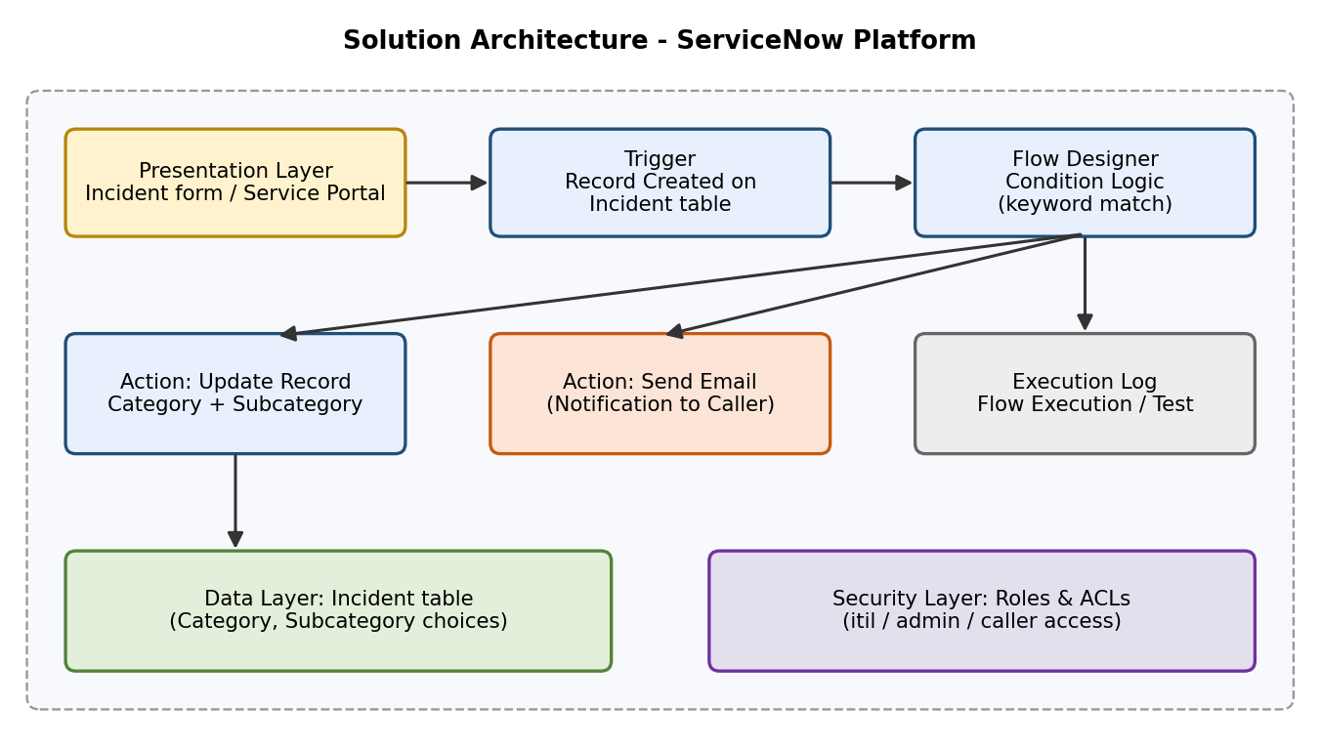
Figure 4.1: Solution Architecture

5. PROJECT PLANNING & SCHEDULING

5.1 Project Planning
The project was organised into five milestones, each treated as an epic with an estimated complexity and duration. The total planned effort is approximately 12 hours 45 minutes.
Milestone | Epic | Complexity | Duration | Key Activities
1 | Requirement Analysis & Planning | Medium | 15 min | Study the helpdesk problem, define required keywords, categories and subcategories, plan the flow.
2 | Backend Development & Configuration | Easy | 7 h 0 min | Set up the ServiceNow instance, configure the Incident table fields, Category and Subcategory choices and the ticket form.
3 | Automation using Flow Designer & Email Notification | Medium | 5 h 0 min | Build the flow, add keyword conditions, update-record actions and the caller email notification.
4 | Testing, Validation & Security | Medium | 15 min | Test each keyword scenario, verify data accuracy, apply role-based access control.
5 | Deployment & Conclusion | Medium | 10 min | Finalize the solution, prepare documentation and demo.

Milestone 1: Requirement Analysis & Planning. Understood how the helpdesk currently handles tickets, identified the manual steps (identify issue type, select category and subcategory, inform the caller) and defined the keyword-to-category rules.
Milestone 2: Backend Development & Configuration. Prepared the data foundation: the ticket form shows only Caller and Short Description to the user, and the Category and Subcategory choice values (Network/WiFi, Hardware/Projector, Access/Forgot Password, Performance/Slow Computer) are made available on the table so the flow can set them.
Milestone 3: Automation using Flow Designer & Email Notification. Created the flow triggered on record creation, added conditions that test the Short Description for each keyword, configured Update Record actions for Category and Subcategory, and added the email notification to the caller.
Milestone 4: Testing, Validation & Security. Validated the end-to-end automation, confirmed data accuracy and ensured that only authorized users can access or modify ticket data.
Milestone 5: Deployment & Conclusion. Deployed the solution to the target environment and finalized the documentation so the project is stable, reusable and ready for demonstration or production use.

6. FUNCTIONAL AND PERFORMANCE TESTING

6.1 Performance Testing
Testing validates that the flow behaves as specified for every keyword, that edge cases are handled safely, and that access control protects ticket data. Each test case is executed by creating a ticket with only Caller Name and Short Description and then checking the resulting record and the flow execution log.
Functional test cases
ID | Test Input (Short Description) | Expected Result | Status
TC-01 | "WiFi not working in lab" | Category = Network, Subcategory = WiFi | Pass / Fail
TC-02 | "Projector not turning on in room 12" | Category = Hardware, Subcategory = Projector | Pass / Fail
TC-03 | "Forgot my Password" | Category = Access, Subcategory = Forgot Password | Pass / Fail
TC-04 | "Unable to Login to portal" | Category = Access, Subcategory = Forgot Password | Pass / Fail
TC-05 | "Computer is very Slow" | Category = Performance, Subcategory = Slow Computer | Pass / Fail
TC-06 | "System keeps Hanging" | Category = Performance, Subcategory = Slow Computer | Pass / Fail
TC-07 | "wifi down" (lower case) | Classified as Network / WiFi (case-insensitive match) | Pass / Fail
TC-08 | "Printer out of ink" (no keyword) | Category and Subcategory left unchanged for manual review | Pass / Fail
TC-09 | Any valid ticket | Caller receives the ticket-creation email | Pass / Fail
TC-10 | Any valid ticket | Flow execution log shows the flow completed successfully | Pass / Fail

Performance and security checks
- Execution time: confirm the flow completes within seconds of ticket creation using the Flow Execution details.
- Volume: create several tickets in quick succession and verify all are classified correctly.
- Data accuracy: compare Category and Subcategory against the keyword mapping table for every test ticket.
- Access control: verify that a standard user cannot edit classification fields, while authorized IT staff can.
- Error handling: confirm that tickets with no matching keyword are not wrongly classified.

Record the actual outcome of each test in the Status column and attach supporting screenshots in Section 7.

7. RESULTS

7.1 Output Screenshots
ServiceNow result screenshots from the implemented ticket classification workflow.
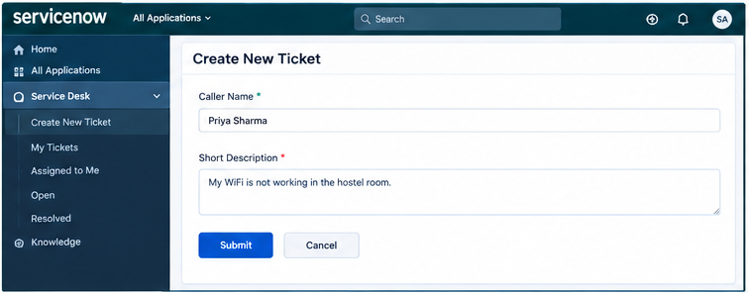
Figure 7.1: Ticket creation form with minimal input (Caller Name and Short Description)
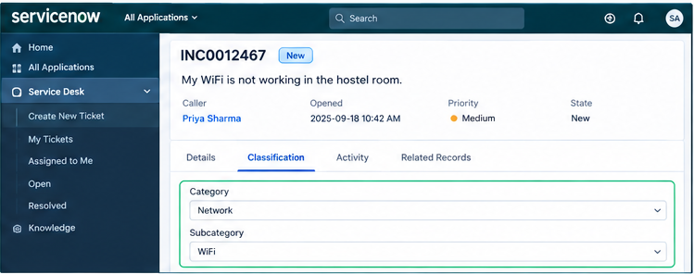
Figure 7.2: Automatically assigned Category and Subcategory (Network / WiFi)
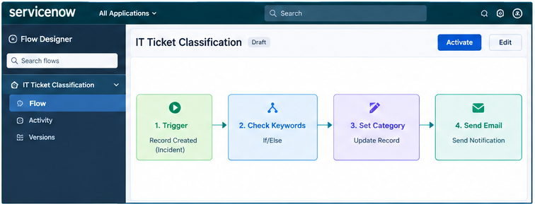
Figure 7.3: Flow Designer flow for automatic classification
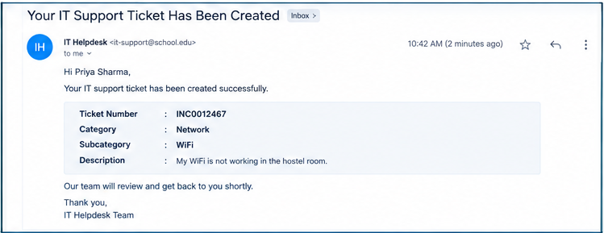
Figure 7.4: Email notification sent to the caller
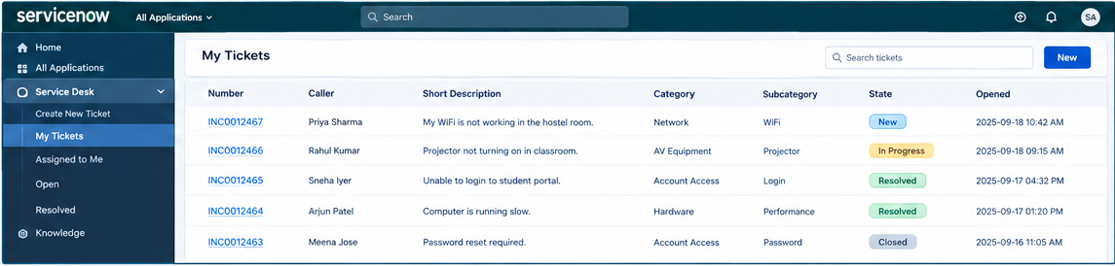
Figure 7.5: My Tickets view showing classified tickets
Summary of results: for every tested keyword the flow assigned the expected Category and Subcategory automatically at the moment of ticket creation, removing the manual triage step.

8. ADVANTAGES & DISADVANTAGES
Advantages | Disadvantages
Eliminates manual categorization of tickets.  Consistent classification with no human error.  Simple form for students and teachers.  Instant acknowledgement to the caller.  No-code, easy to build and maintain.  Scalable to higher ticket volumes.  Easily extended by adding new keyword conditions.  Frees IT staff to focus on resolving issues. | Depends on exact keywords; descriptions without them are not classified.  Cannot understand context, synonyms or spelling mistakes.  A description with several keywords is classified by the first matching condition only.  Limited to the four predefined categories.  Requires ServiceNow access and licensing beyond a developer instance for production.  Rules must be updated manually as new issue types appear.

9. CONCLUSION
The Auto-Ticket Classification project shows that a routine and time-consuming part of IT support can be automated entirely with ServiceNow Flow Designer and no custom code. By asking users for only a Caller Name and Short Description, and then applying keyword rules to assign Category and Subcategory, the solution delivers consistent classification, removes human error and notifies callers immediately.
The project was completed across five milestones covering analysis, backend configuration, flow automation, testing and security, and deployment. The result is a stable, reusable and easily maintainable solution that reduces the manual workload of the school IT helpdesk and scales as the number of requests grows.

10. FUTURE SCOPE
- Extend keyword rules to cover more issue types such as printer, email, software installation, and network cable problems.
- Make keyword matching more robust with synonyms and common misspellings.
- Add automatic priority and urgency assignment (for example, projector failures during class hours).
- Automatically assign tickets to the appropriate support group or technician based on category.
- Integrate machine learning or ServiceNow Predictive Intelligence for context-aware classification.
- Provide a Service Portal or chatbot front end for raising tickets.
- Add dashboards and reports showing ticket volume by category, resolution time and trends.
- Send SMS or Microsoft Teams notifications in addition to email.

11. APPENDIX

Source Code (if any)
The solution is built with Flow Designer and requires no custom source code. The flow configuration is summarised below in pseudo-logic for reference.
Flow: Auto Ticket Classification
Trigger: Incident > Created

IF short_description CONTAINS "WiFi"
category = Network ; subcategory = WiFi
ELSE IF short_description CONTAINS "Projector"
category = Hardware ; subcategory = Projector
ELSE IF short_description CONTAINS "Password" OR "Login"
category = Access ; subcategory = Forgot Password
ELSE IF short_description CONTAINS "Slow" OR "Hanging"
category = Performance ; subcategory = Slow Computer
END IF

Action: Send Email to Caller (ticket created)

